The excel interface tool is an Excel-based database/script program for MAIZSIM that holds the data for 1 or more simulations and builds the input files and file structure to run the model. Note that I have only been able to get it to work with the 32 bit version of MS Office because of a problem of the texture class dll.

The scripts are written in VBA and are located in the VBA Code section of the Excel file (turn on the Developer menu item). Code and data are also included to automatically build the grid files needed for the finite element domain. Each input file has its own sheet. The only files that are not created are the weather files. These must be done separately.

Installation:

Create a folder to hold your maizsim work. Under this folder create two sub-folders:

ExcelInterface and CreateSoils

In the ExcelInterface folder copy the files from the same named folder in the shared google drive or zip file

Read Plant filesV6.xlsm

How to use the Excel tool.docx

Folder structure.docx

Textureclass(32).dll

Dispersivity lookup.xls

You have to edit the excel VBA program so it can find the helper files

Open the file Read Plant filesV6.xlsm and enable the developer tab if it is not already

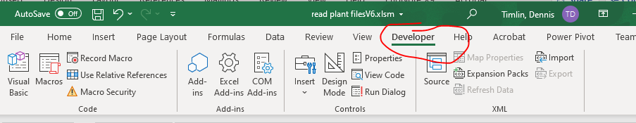

It is not enabled by default, to enable it:

Right click anywhere in the ribbon/menu area and you should see a ‘customize ribbon’ option:

You’ll see this menu. Make sure ‘main tabs’ is selected on the right. Then place a check mark in the developer box if not there. (If it was checked you would have seen the ‘Developer’ Menu item. Click OK to exit.

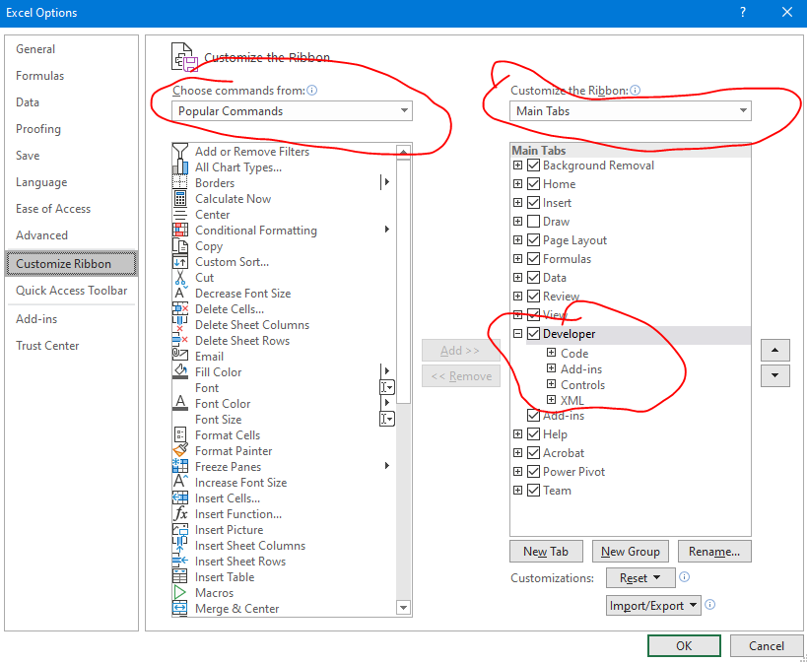

Now click on the ‘Developer’ menu item and you should see ‘Visual Basic’ as the first option. Click on it

This will bring up a new window that looks like this:

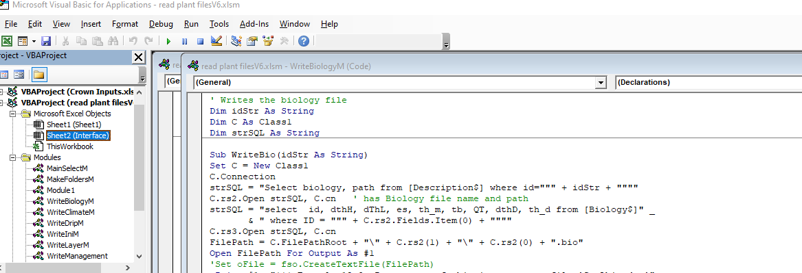

In the left navigation window under modules, look for ‘WriteSolute’ and double click on it. It should bring up the code window for this module:

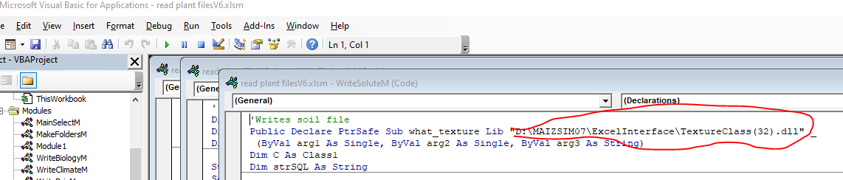

In the circled area you will have to put your location of the textureclass(32).dll file. Make sure it is in quotes and there has to be a space before the “_”. Put in the full path.

Click on the save button (blue disk icon)

This is a summary of the modules

|  |  |
| --- | --- |
| Module 1 | Imports a plant output file and inserts into spreadsheet – this one may not be up to date |
| WriteBiologyM | Writes the biology file |
| WriteIniM | Writes the initialization file |
| WriteSoluteM | Writes the solute file - calls a dll to find soil texture class and also opens  Another spreadsheet to look up dispersivity based on texture class |
| WriteManagement | Writes management files |
| WriteTimeM | Writes the time file |
| WriteVarietyM | Writes Variety file. Note that it inserts some lines of data that are not in the database. This is for manually changing some of the advanced parameterr |
| WriteClimateM | Climate file |
| WriteNitM | Nitrogen file |
| WriteRunM | Writes the run file |
| MakeFoldersM | Creates subfolders |
| MainSelectM | Runs macros for selected id's - choose them from the excel page |
| WriteLayerM | Creates the layer file that is input to the CreateSoils program and writes the batch files needed to run the program |
| WriteDripM | Creates file for drip irrigation if used |

In the CreateSoils folder copy the files from the CreateSoils folder

CreateSoilsFiles.exe

Rosetta.exe

GridGenDll.DLL

Vangenuch.xls

CreateSoil program notes.pdf

The executables and secondary files needed are described below.

The following files are used to create the grid and soil files. These are not executed by the vba code but are executed in a separate DOS command file:

CreateSoilFIles.exe This program calls GridGen.DLL and Rosetta.exe

GridGen.DLL a fortran dll that creates the finite element mesh

Rosetta.exe A program that uses pedotransfer functions and a neural net to estimate soil hydraulic properties from soil texture data. The program (source code was obtained from:

<https://www.ars.usda.gov/pacific-west-area/riverside-ca/agricultural-water-efficiency-and-salinity-research-unit/docs/model/rosetta-model/>

The program was mostly written by Marcel Schapp

The following files are needed by the Excel VBA code:

Dispersivity Lookup.xls This contains one sheet that is a lookup table for soil dispersivity vs soil texture class. It should be in the same folder as the ExcelInterface file.

TextureClass(32).dll This program takes sand, silt and clay values and gives the texture class (silty clay loam, etc). It was originally written by Aris Gerakis, 2001 with help from Brian Baer

(<https://nowlin.css.msu.edu/software/triangle_form.html>)

TextureClass.dll finds the soil texture class and this is used to lookup the correct value of dispersivity in the Dispersivity lookup file.

CreateSoilFiles.exe usage:

The excel interface creates a batch file called grid1.bat. This is an example of the contents:

D:\Maizsim07\CreateSoils\CreateSoilFiles.exe "D:\MAIZSIM07\AgMipEt\Iowa06\Iowa06.lyr" /GN Iowa06 /SN Harps

del output

del element_elm

del grid_bnd

del datagen2.dat

Dir *.* >dir.txt

To use CreateSoilFiles.exe on its own:

The command (see above) is called from the path where soil and grid files should be stored. The command line requires a fully formed path to the executable’s source because the executable is in a different folder than the one where the files are created. The input file (…lyr) also needs a fully formed path. This makes the location of the layer file and location of the program independent of where it is run from. The arguments GN and SN are the grid name and soil name.

Once the grid1.bat files are created in all the subdirectories, you can iterate through the subdirectories and call all the grid files with this script:

*for /R "d:\maizsim07\AgMipLowInputC" %%g in (.) do (*

*pushd %%g*

*echo now in %%g*

*grid1.bat*

*popd*

*)*

Save this into a file called, for example, RunGridBatchFiles.bat

Substitute your file structure for “D:\maizsim07\AgMipLowInputC”

Run the batch file from the root directory (D:\maizsim07 \AgmipLowInputC) in this case).

Excel file sheets (tables)

The first sheet is the Description. This sheet contains the id’s that link the various tables and are used for lookup. The number of rows in this table has to be equal to the number of simulations to be carried out. Also, the filenames for the maizsim input files (output by the excel interface) can be specified here.

The ID is the main identifier and there is one for each simulation. There is no requirement other than each is unique.

The linkages among the rows of data in the sheets are as follows:

[Description]WeatherID

[Description]ClimateID [Climate]ClimateID

[Description]SoilFIle [Soil]SoilName

[Description]Hybrid [Variety]Hybrid

[Description]Biology [Biology]BiologyID

[Description]Solute [Solute]ID

The variable [Description]path is the path name for the simulation files in the directory structure.

Description of variables (note that case should be consistent when using the variable in other sheets):

Description sheet

|  |  |
| --- | --- |
| Name | Description |
| ID | Main Identifyer – a key to relate to variables in other tables |
| WeatherID | Links to row in weather table with weather data, usually the site |
| Hybrid | Variety name |
| VarietyFIle | Name of variety file |
| SOilName | Name of soil |
| SOilFile | Name of the soil file |
| weatherfilename | Name that will be given to the weather file (can be the same for all sims) |
| climatefile | Name given to climate file |
| climateID | Row in climate file with data – one site can have different climateID’s if the climate data are different. |
| Location | Same as site – a name for a location with a lat – lon value |
| NitrogenFIle | Name of the file with the nitrogen solute data |
| Solute | Name of the file with the solute data |
| path | The path under the main folder where the scenario data will be written |
| Biology | ID of the source line in the biology table (sheet) |
| longName | Optional – used by external progams |

|  |  |  |
| --- | --- | --- |
| Name | Description | Commonly used |
| ClimateID | ID to relate to Description table | Y |
| site | Name or code of the site | Y |
| latitude | Latitute (degree, minute) | Y |
| longitude | Longitude (degree, minute) | Y |
| DailyBulb | 1 if daily or hourly wet bulb temps are available | N |
| DailyWInd | 1 if daily or hourly wind values are available | Y |
| RainIntensity | 1 if daily rain intensity values are available. Only used for daily weather data | N |
| DailyConc | 1 if daily rainfall Nitrogen is available | N |
| Furrow | 1 for furrow irrigation | N |
| RelHumid | 1 if Daily or hourly RH values available |  |
| DailyCO2 | 1 if daily or hourly CO2 values are available |  |
| Bsolar | Conversion of solar units converts input value to J/m2 | N |
| Btemp | Conversion of temperature converts to Celsius | N |
| Atemp | Conversion 2 of temperature converts to Celsius | N |
| Erain | Conversion of rain values to cm (if rain is input as mm then Erain is 0.1) | N |
| BWInd | Conversion factor for wind (usually 1) converts input value to km/hr | N |
| BIR | Conversion factor for verage rainfall intensity rate (cm/hr) – keep as 1 | N |
| AvgWind | Average wind (Km/hr) | Y |
| AvgRainRate | Average rainfall rate (used for daily data) cm/hr | Y |
| ChemCOnc | Nitrogen concentration in rainfall (usually zero) (mg/L) | N |
| RH | Average RH when daily/hourly values not available (%) | Y |
| AvgCO2 | Average CO2 when daily/average not available | Y |

Structure of Excel database

The first page (sheet) of the excel interface has a form for entry of the parameters needed to run the interface. The parameters are file names and locations.

The “input excel file” is the excel file with the data for the simulations

Root path is the path below which the paths for the simulations exist. Each simulation has its own path

The maizsim path is the path where the 2dsoil.exe file exists, usually the same as the root path

Create soils and Excel interface are the locations of the CreateSoilFiles.exe and the excel interface file (read plant filesV4.xlsm).

If you click the select ID’s and run macros button, the column C will fill with ID’s and a selection window will open allowing you to select one or more of the sims to run. The ‘Run Macros for all ID’s’ is not fully functional yet.

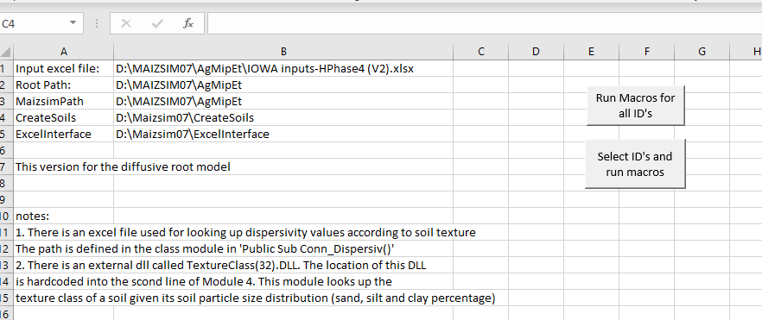

Here the base folder is D:\maizsim07\AgmipLowInputC_2 and the interface created the paths BEOU1401, etc and filled them with the input files.

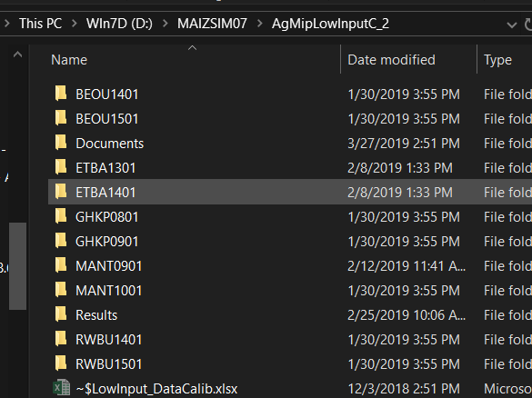

This is what a folder looks like after it is filled with files.

